**Assignment – 3**

Python Programming

|  |  |
| --- | --- |
| Assignment Date |  |
| Student Name | SAITEJA.K |
| Student Roll Number | 111519104067 |
| Maximum Marks | 2 Marks |

# Problem Statement: Abalone Age Prediction Description:

**Predicting the age of abalone from physical measurements. The age of abalone is determined by cutting the shell through the cone, staining it, and counting the number of rings through a microscope -- a boring and time-consuming task. Other measurements, which are easier to obtain, are used to predict age. Further information, such as weather patterns and location (hence food availability) may be required to solve the problem.**

# Importing Modules

In [ ]:

**import** pandas

seaborn **as**

**as** pd **import**

sns **import**

matplotlib.pyplot **as** plt **import**

numpy **as** np

# Dataset has been downloaded

In [ ]:

*#Name of the dataset: abalone.csv*

# Load the dataset into the tool

In [ ]:

data**=**pd**.**read_csv("abalone.csv") data**.**head()

**Whole Shucked Viscera Shell**

Out []: **Sex Length Diameter Height Rings weight weight weight weight**

**0** M 0.455 0.365 0.095 0.5140 0.2245 0.1010 0.150 15

**1** M 0.350 0.265 0.090 0.2255 0.0995 0.0485 0.070 7

**2** F 0.530 0.420 0.135 0.6770 0.2565 0.1415 0.210 9

**3** M 0.440 0.365 0.125 0.5160 0.2155 0.1140 0.155 10

**4** I 0.330 0.255 0.080 0.2050 0.0895 0.0395 0.055 7

## Let's know the shape of the data

In [ ]:

data**.**shape

(4177, 9) Out[

]:

## One additional task is that, we have to add the "Age" column using "Rings" data. We just have to add '1.5' to the ring data

In [ ]:

Age**=**1.5**+**data**.**Rings data["Age"]**=**Age data**=**data**.**rename(columns **=** {'Whole weight':'Whole_weight','Shucked weight': 'Sh

'Shell weight': 'Shell_weight'}) data**=**data**.**drop(columns**=**["Rings"],axis**=**1) data**.**head()

Out[ ]: **Sex Length Diameter Height Whole_weight Shucked_weight Viscera_weight Shell_weig**

**0** M 0.455 0.365 0.095 0.5140 0.2245 0.1010 0.1

**1** M 0.350 0.265 0.090 0.2255 0.0995 0.0485 0.0

**2** F 0.530 0.420 0.135 0.6770 0.2565 0.1415 0.2

**3** M 0.440 0.365 0.125 0.5160 0.2155 0.1140 0.1

**4** I 0.330 0.255 0.080 0.2050 0.0895 0.0395 0.0

# Perform Below Visualizations.

1. **Univariate Analysis #**

The term univariate analysis refers to the analysis of one variable. You can remember this

because the prefix “uni” means “one.” There are three common ways to perform

univariate analysis on one variable: 1. Summary statistics – Measures the center and spread of values.

# #

## Histogram

In [ ]:

sns**.**displot(data["Age"], color**=**'darkorange')

<seaborn.axisgrid.FacetGrid at 0x7fd3f837a430>

Out[ ]:

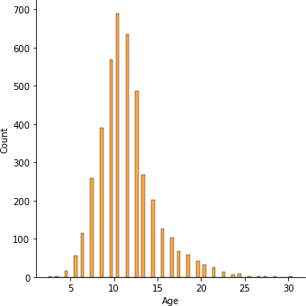

In [ ]:

sns**.**histplot(y**=**data**.**Age,color**=**'pink')

<AxesSubplot:xlabel='Count', ylabel='Age'> Out[

]:

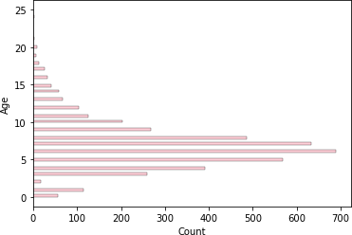

In [ ]:

sns**.**histplot(x**=**data**.**Age,color**=**'green')

Out[ ]: < AxesSubplot:xlabel='Age', ylabel='Count'>

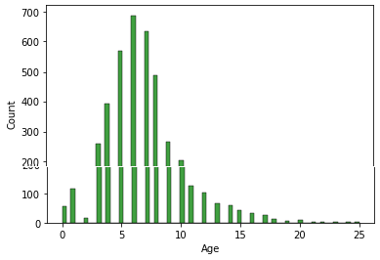

## Boxplot

In [ ]:

sns**.**boxplot(x**=**data**.**Age,color**=**'pink')

<AxesSubplot:xlabel='Age'> Out[

]:

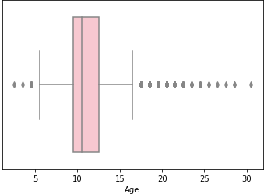

## Countplot

In [ ]:

sns**.**countplot(x**=**data**.**Age)

<AxesSubplot:xlabel='Age', ylabel='count'> Out[

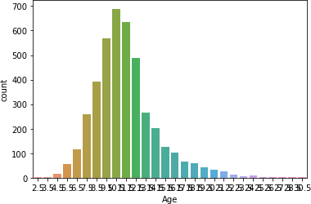]:

# Bi-Variate Analysis #

Image result for bivariate analysis in python It is a methodical statistical technique applied to a pair of variables (features/ attributes) of data to determine the empirical relationship between them. In order words, it is meant to determine any concurrent relations (usually over and above a simple correlation analysis).

# #

## Barplot

In [ ]:

sns**.**barplot(x**=**data**.**Height,y**=**data**.**Age)

<AxesSubplot:xlabel='Height', ylabel='Age'> Out[

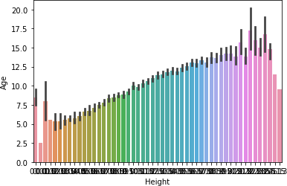]:

## Linearplot

In [ ]:

sns**.**lineplot(x**=**data**.**Age,y**=**data**.**Height, color**=**'purple')

<AxesSubplot:xlabel='Age', ylabel='Height'> Out[

]:

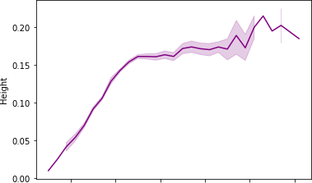



## Scatterplot

In [ ]:

sns**.**scatterplot(x**=**data**.**Age,y**=**data**.**Height,color**=**'green')

<AxesSubplot:xlabel='Age', ylabel='Height'> Out[

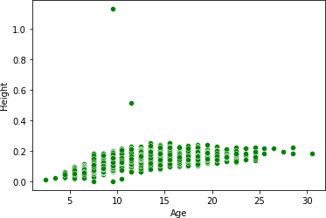]:

## Pointplot

In [ ]:

sns**.**pointplot(x**=**data**.**Age, y**=**data**.**Height, color**=**"blue")

<AxesSubplot:xlabel='Age', ylabel='Height'> Out[

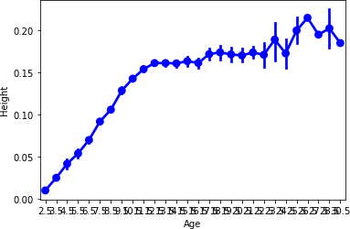]:

## Regplot

In [ ]:

sns**.**regplot(x**=**data**.**Age,y**=**data**.**Height,color**=**'orange')

<AxesSubplot:xlabel='Age', ylabel='Height'> Out[

]:

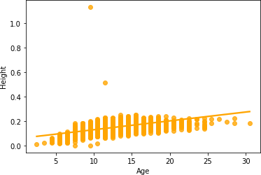

# Multi-Variate Analysis

**#**

Multivariate analysis is based in observation and analysis of more than one statistical outcome variable at a time. In design and analysis, the technique is used to perform trade studies across multiple dimensions while taking into account the effects of all variables on the responses of interest.

# #

## Pairplot

In [ ]:

sns**.**pairplot(data**=**data[["Height","Length","Diameter","Age","Whole_weight","Shuc

<seaborn.axisgrid.PairGrid at 0x7fd3d93e1040>

Out[ ]:

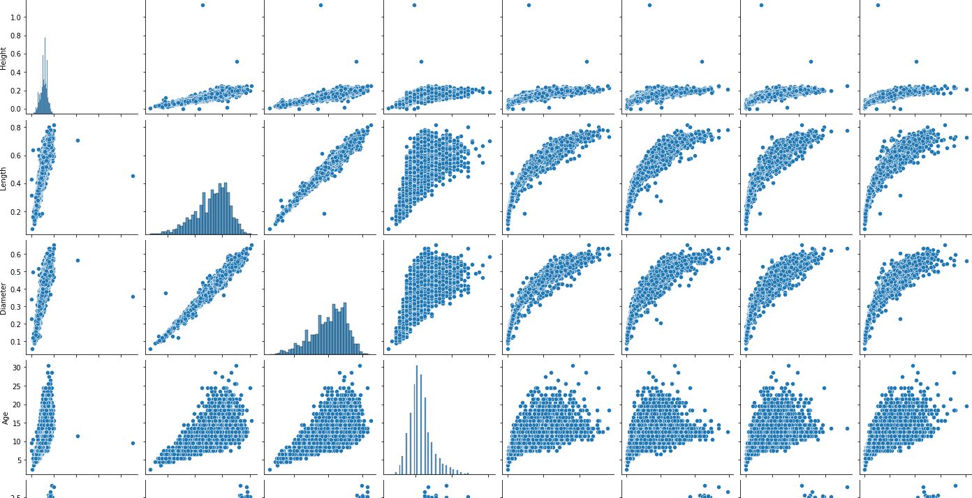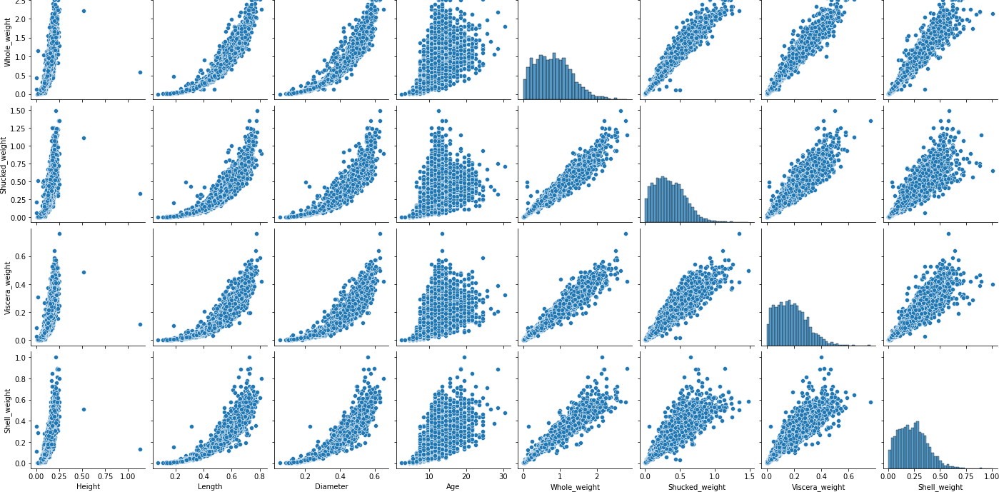

In [ ]:

sns**.**pairplot(data**=**data[["Height","Length","Diameter","Age","Whole_weight","Shuc

<seaborn.axisgrid.PairGrid at 0x7fd39840c790>

Out[ ]:

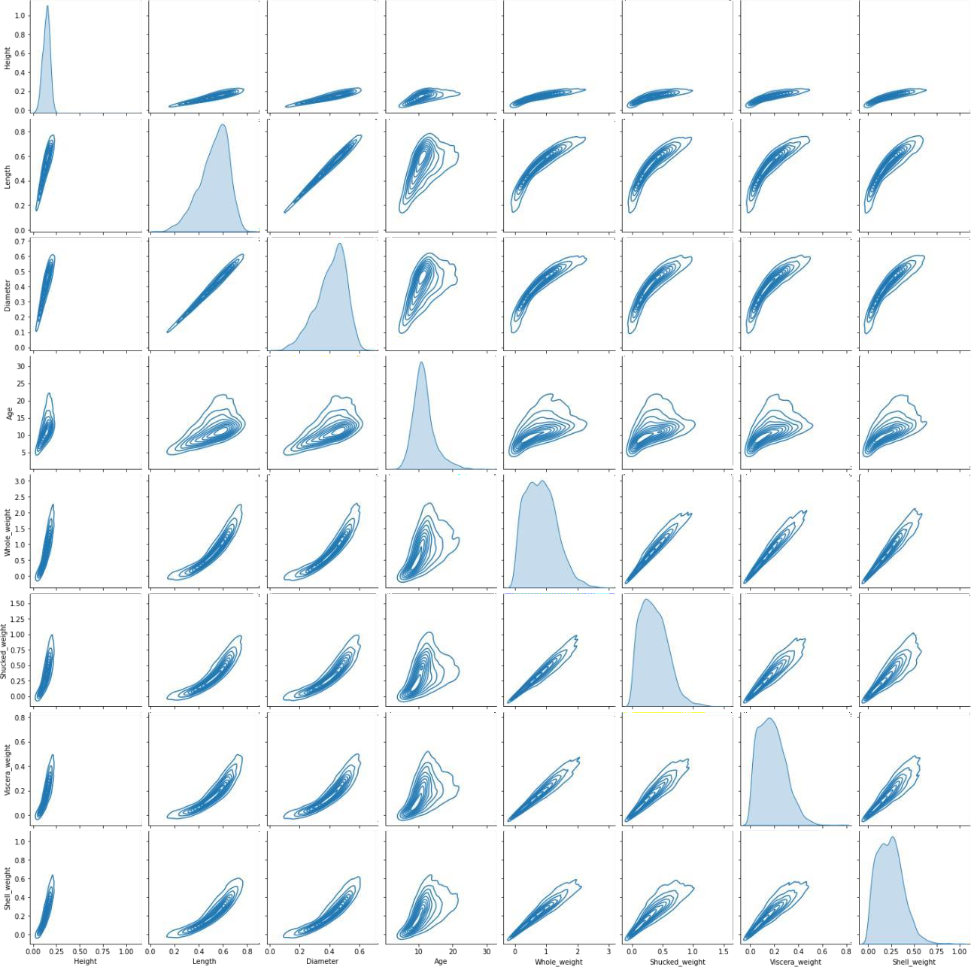

# Perform descriptive statistics on the dataset

In [ ]:

data**.**describe(include**=**'all')

Out[ ]: **Sex Length Diameter Height Whole_weight Shucked_weight Viscera_**

|  |  |  |  |  |  |  |
| --- | --- | --- | --- | --- | --- | --- |
| **count** 4177 4177.000000 4177.000000 4177.000000 | | |  | 4177.000000 | 4177.000000 | 4177. |
| 3 **unique** | | | | | | |
|  | NaN | NaN | NaN | NaN | NaN |  |
| **top** M |  |  |  |  |  |  |
|  | NaN | NaN | NaN | NaN | NaN |  |
| **freq** 1528 |  |  |  |  |  |  |
|  | NaN | NaN | NaN | NaN | NaN |  |
| **mean** NaN | 0.523992 | 0.407881 | 0.139516 | 0.828742 | 0.359367 | 0. |
| **std** NaN | 0.120093 | 0.099240 | 0.041827 | 0.490389 | 0.221963 | 0. |
| **min** NaN | 0.075000 | 0.055000 | 0.000000 | 0.002000 | 0.001000 | 0. |

|  |  |  |  |  |  |  |
| --- | --- | --- | --- | --- | --- | --- |
| **25%** NaN | 0.450000 | 0.350000 | 0.115000 | 0.441500 | 0.186000 | 0. |
| **50%** NaN | 0.545000 | 0.425000 | 0.140000 | 0.799500 | 0.336000 | 0. |
| **75%** NaN | 0.615000 | 0.480000 | 0.165000 | 1.153000 | 0.502000 | 0. |
| **max** NaN | 0.815000 | 0.650000 | 1.130000 | 2.825500 | 1.488000 | 0. |

# Check for Missing values and deal with them

In [ ]:

|  |  |
| --- | --- |
| data**.**isnull()**.**sum() | |
| Sex | 0 |
| Length | 0 |
| Diameter | 0 |
| Height | 0 |
| Whole_weight | 0 |
| Shucked_weight | 0 |
| Viscera_weight | 0 |
| Shell_weight | 0 |
| Age | 0 |
| dtype: int64  **6. Find the** | **outliers and replace them outliers** |
| outliers**=**data**.**quantile(q**=**(0.25,0.75)) outliers  **Length Diameter Height Whole_weight Shucked_weight Viscera_weight Shell_weight** | |

Out[ ]:

In [ ]:

Out[ ]:

|  |  |  |  |  |  |  |  |
| --- | --- | --- | --- | --- | --- | --- | --- |
| **0.25** | 0.450 | 0.35 | 0.115 | 0.4415 | 0.186 | 0.0935 | 0.130 |
| **0.75** | 0.615 | 0.48 | 0.165 | 1.1530 | 0.502 | 0.2530 | 0.329 |

In [ ]:

a **=** data**.**Age**.**quantile(0.25) b **=** data**.**Age**.**quantile(0.75) c **=** b **-** a

lower_limit **=** a **-** 1.5 **\*** c data**.**median(numeric_only**=True**)

|  |  |
| --- | --- |
| Length Out[  ]:  Diameter Height Whole_weight Shucked_weight Viscera_weight  Shell_weight Age  dtype: float64 | 0.5450  0.4250  0.1400  0.7995  0.3360  0.1710  0.2340  10.5000 |

In [ ]:

data['Age'] **=** np**.**where(data['Age'] **<** lower_limit, 7, data['Age']) sns**.**boxplot(x**=**data**.**Age,showfliers **= False**)

<AxesSubplot:xlabel='Age'> Out[

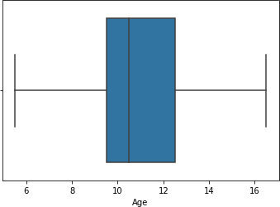]:

# Check for Categorical columns and perform encoding

In [

|  |  |  |  |  |  |  |  |  |  |  |
| --- | --- | --- | --- | --- | --- | --- | --- | --- | --- | --- |
| ]:  ]: | data**.**head() | | |  |  |  |  |  |  |  |
|  | **Sex** | | **Length** | **Diameter** | **Height** | **Whole_weight** | **Shucked_weight** | **Viscera_weight** | **Shell_weig** |  |
|  | **0** | M | 0.455 | 0.365 | 0.095 | 0.5140 | 0.2245 | 0.1010 | 0.1 |  |
| **1** | M | 0.350 | 0.265 | 0.090 | 0.2255 | 0.0995 | 0.0485 | 0.0 |
| **2** | F | 0.530 | 0.420 | 0.135 | 0.6770 | 0.2565 | 0.1415 | 0.2 |
| **3** | M | 0.440 | 0.365 | 0.125 | 0.5160 | 0.2155 | 0.1140 | 0.1 |
| **4** | I | 0.330 | 0.255 | 0.080 | 0.2050 | 0.0895 | 0.0395 | 0.0 |

Out[

In [ ]:

**from** sklearn.preprocessing **import** LabelEncoder lab **=** LabelEncoder()

data**.**Sex **=** lab**.**fit_transform(data**.**Sex)

data**.**head()

Out[ ]: **Sex Length Diameter Height Whole_weight Shucked_weight Viscera_weight Shell_weig**

|  |  |  |  |  |  |  |  |  |
| --- | --- | --- | --- | --- | --- | --- | --- | --- |
| **0** | 2 | 0.455 | 0.365 | 0.095 | 0.5140 | 0.2245 | 0.1010 | 0.1 |
| **1** | 2 | 0.350 | 0.265 | 0.090 | 0.2255 | 0.0995 | 0.0485 | 0.0 |
| **2** | 0 | 0.530 | 0.420 | 0.135 | 0.6770 | 0.2565 | 0.1415 | 0.2 |
| **3** | 2 | 0.440 | 0.365 | 0.125 | 0.5160 | 0.2155 | 0.1140 | 0.1 |
| **4** | 1 | 0.330 | 0.255 | 0.080 | 0.2050 | 0.0895 | 0.0395 | 0.0 |

# Split the data into dependent and independent variables

In [ ]:

y **=** data["Sex"]

y**.**head()

|  |  |  |
| --- | --- | --- |
| 0  Out[ | 2  ]: |  |
| 1 | 2 |
| 2 | 0 |
| 3 | 2 |
| 4 | 1 |
|  |  | Name: Sex, dtype: int64 |
| In [ | ]: | x**=**data**.**drop(columns**=**["Sex"],axis**=**1) x**.**head () |

Out[ ]: **Length Diameter Height Whole_weight Shucked_weight Viscera_weight Shell_weight A**

**0** 0.455 0.365 0.095 0.5140 0.2245 0.1010 0.150

**1** 0.350 0.265 0.090 0.2255 0.0995 0.0485 0.070

**2** 0.530 0.420 0.135 0.6770 0.2565 0.1415 0.210

**3** 0.440 0.365 0.125 0.5160 0.2155 0.1140 0.155

**4** 0.330 0.255 0.080 0.2050 0.0895 0.0395 0.055

# Scale the independent variables

In [ ]:

**from** sklearn.preprocessing **import** scale

X_Scaled **=** pd**.**DataFrame(scale(x), columns**=**x**.**columns) X_Scaled**.**head()

Out[ ]: **Length Diameter Height Whole_weight Shucked_weight Viscera_weight Shell_weigh**

|  |  |  |  |  |  |
| --- | --- | --- | --- | --- | --- |
|  | **0** | -0.574558 -0.432149 -1.064424 | -0.641898 | -0.607685 | -0.726212 |
| -0.63821 | **1** | -1.448986 -1.439929 -1.183978 | -1.230277 | -1.170910 | -1.205221 |

-1.21298

**2** 0.050033 0.122130 -0.107991 -0.309469 -0.463500 -

0.356690 -0.20713

|  |  |  |  |  |  |  |
| --- | --- | --- | --- | --- | --- | --- |
|  |  | **3** | -0.699476 -0.432149 -0.347099 | -0.637819 | -0.648238 | -0.607600 |
| -0.60229 |  |  |  |  |  |
| -1.32075 | **4** | -1.615544 -1.540707 -1.423087 | -1.272086 | -1.215968 | -1.287337 |
|  |  |  |  |  |  |  |

# Split the data into training and testing

In [ ]:

**from** sklearn.model_selection **import** train_test_split

X_Train, X_Test, Y_Train, Y_Test **=** train_test_split(X_Scaled, y, test_size**=**0.2,

In [ ]:

X_Train**.**shape,X_Test**.**shape

Out[ ]:

In [ ]:

((3341, 8), (836, 8))

((3341,), (836,))

Y_Train**.**shape,Y_Test**.**shape

In [ ]:

X_Train **.**head ()

|  |  |  |  |  |  |
| --- | --- | --- | --- | --- | --- |
| Out[ ]: | **Length Diameter Height** | **Whole_weight** | **Shucked_weight** | **Viscera_weight** | **Shell_w** |
| Out[ ]: | **3141** -2.864726 -2.750043 -1.423087 | -1.622870 | -1.553902 | -1.583867 | -1.64 |

|  |  |  |  |  |  |  |  |
| --- | --- | --- | --- | --- | --- | --- | --- |
| **3521** -2.573250 -2.598876 -2.020857 | | | | -1.606554 | -1.551650 | -1.565619 | -1.62 |
| **883** | 1.132658 | 1.230689 | 0.728888 | 1.145672 | 1.041436 | 0.286552 | 1.53 |
| **3627** | 1.590691 | 1.180300 | 1.446213 | 2.164373 | 2.661269 | 2.330326 | 1.37 |
| **2106** | 0.591345 | 0.474853 | 0.370226 | 0.432887 | 0.255175 | 0.272866 | 0.90 |

In [ ]:

Out[ ]:

**668** 0.216591 0.172519 0.370226 0.181016 -0.368878 0.569396 0.69

|  |  |  |  |  |  |  |
| --- | --- | --- | --- | --- | --- | --- |
| X_Test**.**head() |  |  |  |  |  |  |
| **Length Diameter** | **Height** | **Whole_weight** | **Shucked_weight** | **Viscera_weight** | **Shell_w** |  |

**1580** -0.199803 -0.079426 -0.466653 -0.433875 -0.443224 -0.343004 -0.32

**3784** 0.799543 0.726798 0.370226 0.870348 0.755318 1.764639 0.56

**463** -2.531611 -2.447709 -2.020857 -1.579022 -1.522362 -1.538247 -1.57

**2615** 1.007740 0.928354 0.848442 1.390405 1.415417 1.778325 0.99

In [ ]:

Y_Train**.**head()

3141 1

Out[ ]:

3521 1

883 2

3627 2

2106 2

Name: Sex, dtype: int64

In [ ]:

Y_Test**.**head()

668 2

Out[ ]:

1580 1

3784 2

463 1

2615 2

Name: Sex, dtype: int64

# Build the Model

In [ ]:

**from** sklearn.ensemble **import** RandomForestClassifier

model **=** RandomForestClassifier(n_estimators**=**10,criterion**=**'entropy')

In [ ]:

model**.**fit(X_Train,Y_Train)

RandomForestClassifier(criterion='entropy', n_estimators=10)

Out[ ]:

y_predict **=** model**.**predict(X_Test)

In [ ]:

In [ ]:

y_predict_train **=** model**.**predict(X_Train)

# Train the Model

In [ ]:

**from** sklearn.metrics **import** accuracy_score,confusion_matrix,classification_repo

In [ ]:

print('Training accuracy: ',accuracy_score(Y_Train,y_predict_train))

Training accuracy: 0.9787488775815624

# Test the Model

In [ ]:

print('Testing accuracy: ',accuracy_score(Y_Test,y_predict))

Testing accuracy: 0.5526315789473685

# Measure the performance using Metrics

In [ ]:

pd**.**crosstab(Y_Test,y_predict)

|  |  |  |  |  |
| --- | --- | --- | --- | --- |
| Out[ ]: **col_0**  **Sex** | **0** | **1** | **2** |  |
| **0** | 122 |  | 29 | 98 |
| **1** | 37 217 |  | 37 |  |
| **2** | 120 |  | 53 123 |  |

In [ ]:

print(classification_report(Y_Test,y_predict))

precision recall f1-score support

|  |  |  |  |  |
| --- | --- | --- | --- | --- |
| 0 | 0.44 | 0.49 | 0.46 | 249 |
| 1 | 0.73 | 0.75 | 0.74 | 291 |
| 2 | 0.48 | 0.42 | 0.44 | 296 |
| accuracy |  |  | 0.55 | 836 |
| macro avg | 0.55 | 0.55 | 0.55 | 836 |
| weighted avg | 0.55 | 0.55 | 0.55 | 836 |